Auto-antonyms (Contronyms)

What is Auto-antonyms (Contronyms)
# Source: AI Source: Provided by: [Data Path: Persons Table -> ID Column: 1, Name_En Column: Motasem Essam] -> From: [Chatgpt (GPT-4-turbo)] on [7/30/2025]
Auto-antonyms, also called contronyms, are single words that contain two opposite or contradictory meanings, depending on the context in which they are used.

📊 Overview Table
# Source: AI Source: Provided by: [Data Path: Persons Table -> ID Column: 1, Name_En Column: Motasem Essam] -> From: [Chatgpt (GPT-4-turbo)] on [7/30/2025]
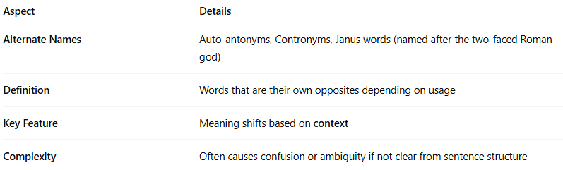
Aspect | Details
Alternate Names | Auto-antonyms, Contronyms, Janus words (named after the two-faced Roman god)
Definition | Words that are their own opposites depending on usage
Key Feature | Meaning shifts based on context
Complexity | Often causes confusion or ambiguity if not clear from sentence structure

🧠 Examples of Auto-antonyms (Contronyms)
# Source: AI Source: Provided by: [Data Path: Persons Table -> ID Column: 1, Name_En Column: Motasem Essam] -> From: [Chatgpt (GPT-4-turbo)] on [7/30/2025]
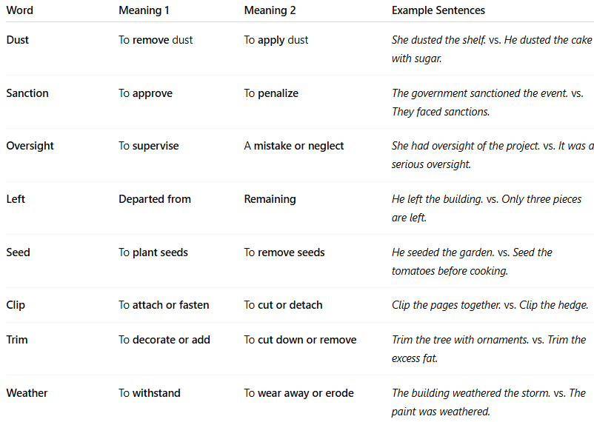
Word | Meaning 1 | Meaning 2 | Example Sentences
Dust | To remove dust | To apply dust | She dusted the shelf. vs. He dusted the cake with sugar.
Sanction | To approve | To penalize | The government sanctioned the event. vs. They faced sanctions.
Oversight | To supervise | A mistake or neglect | She had oversight of the project. vs. It was a serious oversight.
Left | Departed from | Remaining | He left the building. vs. Only three pieces are left.
Seed | To plant seeds | To remove seeds | He seeded the garden. vs. Seed the tomatoes before cooking.
Clip | To attach or fasten | To cut or detach | Clip the pages together. vs. Clip the hedge.
Trim | To decorate or add | To cut down or remove | Trim the tree with ornaments. vs. Trim the excess fat.
Weather | To withstand | To wear away or erode | The building weathered the storm. vs. The paint was weathered.

✅ Summary:
# Source: AI Source: Provided by: [Data Path: Persons Table -> ID Column: 1, Name_En Column: Motasem Essam] -> From: [Chatgpt (GPT-4-turbo)] on [7/30/2025]
- Contronyms can enrich language but also introduce ambiguity.
- Understanding depends on context, tone, and syntax.

